|  |  |  |
| --- | --- | --- |
| SCHOOL OF INFORMATION AND TECHNOLO/GY | | |
| NAME: LAURIANO, Ryan | DATE PERFORMED:08/22/2024 | 50/50 |
| Section: IDC2 | DATE SUBMITTED:08/22/2024 |

# SYSADM1 – Introduction to File Systems in Windows and Linux

# Requirement:

* A virtual machine running Linux and Windows OS

# Instructions:

**Part A: Windows File System**

1. **Open File Explorer:** Click the File Explorer icon on your desktop or press the Windows key + E.
2. **Navigate to your Documents folder:** This is usually the default location for user files.
3. **Create a new folder:** Right-click in an empty space, select "New," then "Folder." Name it "Lab1_Windows."

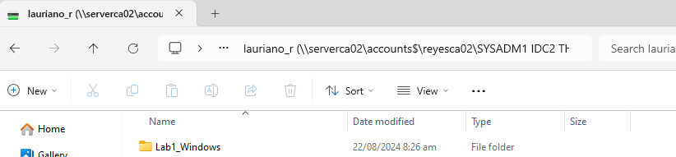

1. **Create a text file:** Right-click in the "Lab1_Windows" folder, select "New," then "Text Document." Rename it to "info.txt."

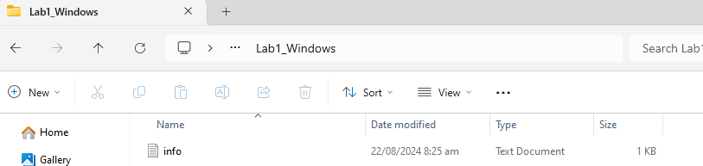

1. **Open the text file:** Double-click the "info.txt" file to open it in Notepad.
2. **Type some text:** Write a short paragraph about yourself or the purpose of the file.

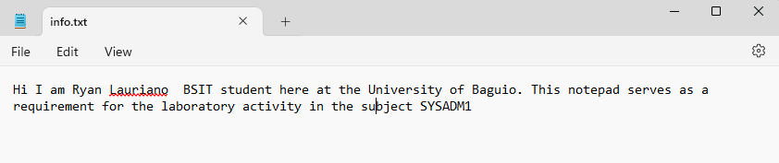

1. **Save the file:** Close the Notepad window and save the changes.
2. **Create a subfolder:** Create a new folder inside "Lab1_Windows" called "Data."

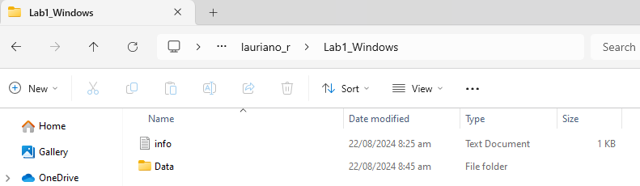

1. **Copy the text file:** Copy the "info.txt" file to the "Data" subfolder.
2. **Rename the copied file:** Rename the copied file to "data.txt.

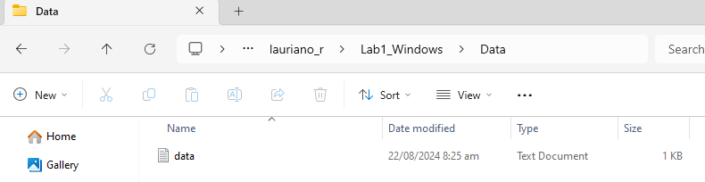

1. Create a folder named "LabFiles" with subfolders for each file type. Use the internet for the resources of the files listed below.

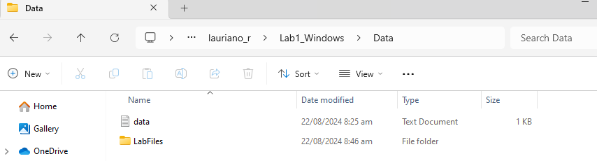

**LabFiles**

* 1. **Text**
     1. large_text.txt
     2. small_text.txt
     3. code.cpp

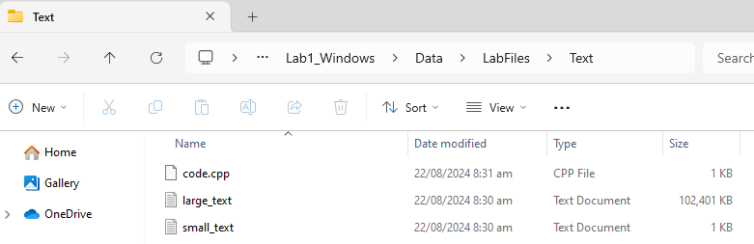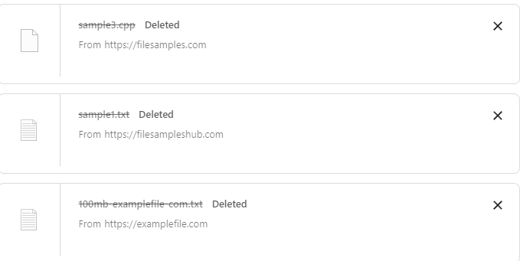

* 1. **Images**
     1. image1.jpg
     2. image2.png
     3. image3.bmp

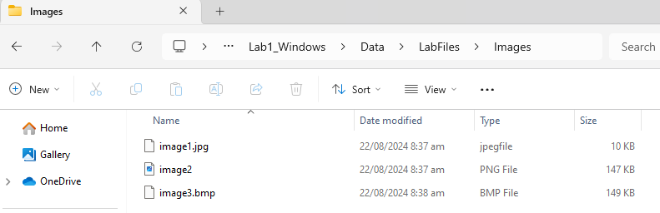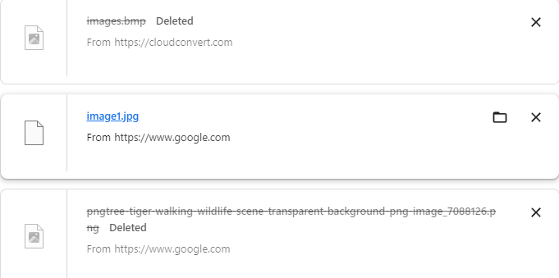

* 1. **Audio**
     1. song.mp3
     2. speech.wav

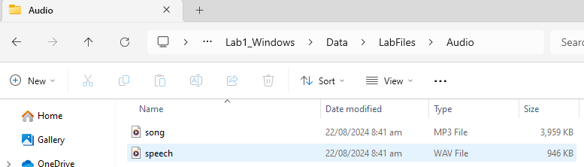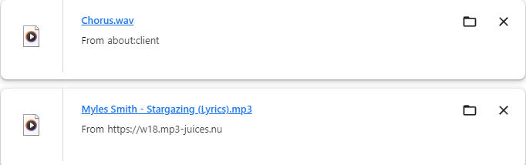

* 1. **Video**
     1. clip.mp4

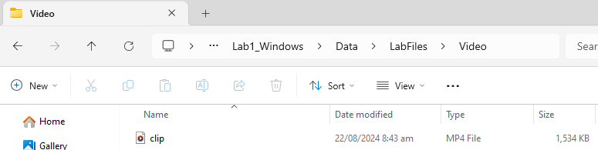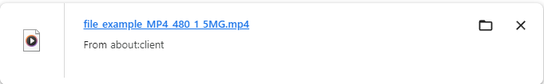

1. **Check file properties:** Right-click on the "info.txt" file and select "Properties." Explore the General, Details, and Security tabs to understand file attributes like creation date, size, and read-only status.
2. **Change file attributes:** Try changing the file attributes (e.g., read-only, hidden) using the Properties dialog. Observe the changes in File Explorer.

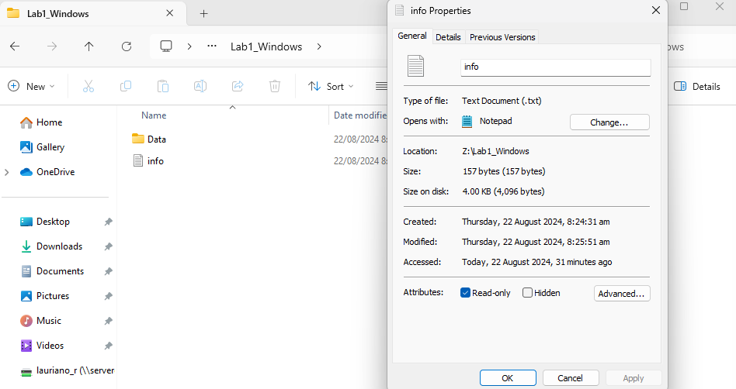 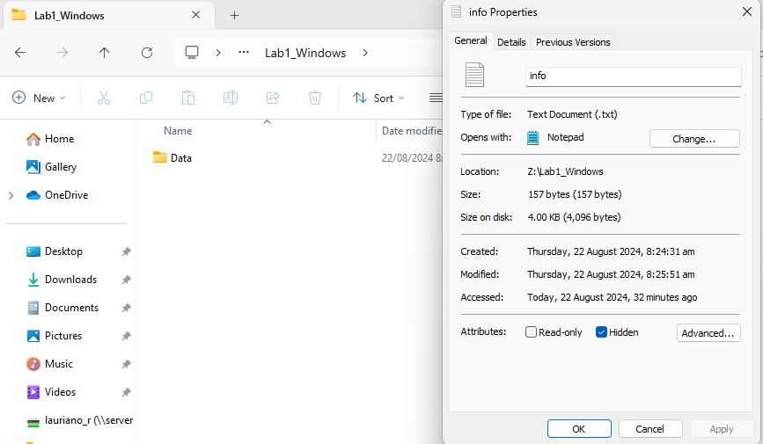

***When changing the file attribute to hidden the document in the File Explorer disappears and when you change it back to Read Only it appears again.***

1. **Share the folder:** Right-click on the "Lab1_Windows" folder, select "Properties," and then the "Sharing" tab. Share the folder with a specific user or group, setting appropriate permissions (e.g., Read, Write, Full control)
2. **Create an archive:** Use WinRAR or 7-Zip to create a compressed archive of the "Lab1_Windows" folder.

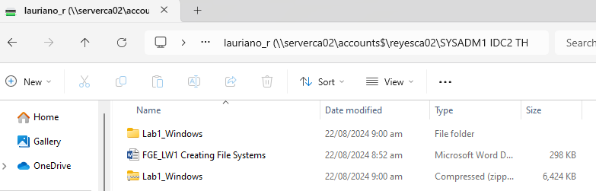

1. **Extract an archive:** Create a new folder, then extract the created archive into it.

Part B. Create a log report structure

|  |  |  |  |  |  |  |
| --- | --- | --- | --- | --- | --- | --- |
| **LOG REPORT** | | | | | | |
| **ID** | **Task Description** | **Date and Time** | **Modifications** | **Status** | **Remarks** | **Properties (After all actions)** |
| **1** | Opened File Explorer | Thursday, ‎22 ‎August ‎2024, 08:49 AM |  | Completed | Opened Successfully |  |
| **2** | New Folder named “Lab1_Windows” | Thursday, ‎22 ‎August ‎2024, ‏‎8:24:03 am |  | Completed | Folder "Lab1_Windows" created. | Size: 106 MB  Contains: 11 Files, 6 Folders |
| **3** | Created a text file named "info.txt" in "Lab1_Windows" | Thursday, ‎22 ‎August ‎2024, ‏‎8:24:31 am | ‎Thursday, ‎22 ‎August ‎2024, ‏‎8:25:51 am | Completed | File "info.txt" created and modified in "Lab1_Windows" | Size: 157 bytes  Contains: |
| **4** | Created a subfolder named "Data" in "Lab1_Windows" | Thursday, ‎22 ‎August ‎2024, ‏‎8:26:04 am |  |  | Folder "Data" created within "Lab1_Windows". | Size: 106 MB  Contains: 10 Files, 5 Folders |
| **5** | Copied "info.txt" to "Data" subfolder | ‎Thursday, ‎22 ‎August ‎2024, ‏‎9:16:47 am |  | Copied with no issues | No missing data from the copied data. | Size: 157 bytes |
| **6** | Rename copied file to "data.txt" |  | ‎Thursday, ‎22 ‎August ‎2024, ‏‎9:16:47 am | Successfully renamed | Successfully renamed. |  |
| **7** | Created" LabFiles" folder with subfolders for file types | Thursday, ‎22 ‎August ‎2024, ‏‎9:16:47 am |  |  | Successfully created. | Size: 106 MB  Contains: 9 Files, 4 Folders |
| **8** | Created Audio Folder within LabFiles | Thursday, ‎22 ‎August ‎2024, ‏‎9:16:47 am |  | Success | Contains the files:  Song.mp3  Speech.wav | Size: 4.78 MB  Contains: 2 Files, 0 Folders |
| **9** | Created Images Folder within LabFiles | ‎Thursday, ‎22 ‎August ‎2024, ‏‎9:16:48 am |  | Success | Contains the files:  Image1.jpg image2.png image3.bmp | Size: 304 KB  Contains: 3 Files, 0 Folders |
| **10** | Created Text Folder within LabFiles | Thursday, ‎22 ‎August ‎2024, ‏‎9:16:48 am |  | Success | Contains the files:  Code.cpp large_text.txt small_text.txt | Size: 100 MB  Contains: 3 Files, 0 Folders |
| **11** | Created Video Folder within LabFiles | ‎Thursday, ‎22 ‎August ‎2024, ‏‎9:16:55 am |  | Success | Contains the files:  Clip.mp4 | Size: 1.49 MB  Contains: 1 Files, 0 Folders |
| **12** |  |  |  |  |  |  |
| **PROBLEMS ENCOUNTERED** | | | | | | |
| **ID** | **Problem** | **Actions Taken** | **Result** | **Remarks** | | |
| **1** | Sharing Tab missing in the Properties Tab | Attempted to Troubleshoot. | Failed. | Network Sharing and Register Editor access is closed. Need authorization from Admin.  **Possible solutions can be found in the internet however it still needs authorization access from admin. | | |
| **2** | Closing of File Explorer once clicked on a Zip File. | Used a 3rd party software to unzip the Zipped file. | Success. Complete data no loss. | No remarks | | |
| **3** |  |  |  |  | | |